Supplemental Form E
21st Century Community Learning Centers
Proposal Workshop Registration Form
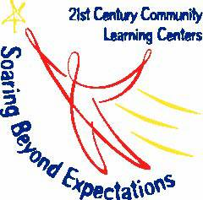

Title: FY16 21st CCLC Proposal Workshop
Date: September 19, 2014
Time: 9:00 AM to 5:00 PM

This registration form must be submitted for each organization or agency attending the workshop. Space is limited to only three (3) participants per agency. There will be no on-site registration.

The registration deadline is Friday, September 12, 2014.

Workshop Site (Please place an ‘X’ next to the location you plan to attend**):
___ Atlanta  GaDOE  205 Jesse Hill Jr. Drive SE  100 Twin Towers West  Atlanta, GA 30334  20th Floor  Floyd Room  Room Capacity: 100 |  | ___ Albany  Isabella Complex: Room 4  Dougherty County Schools  300 Cason Street  Albany, GA 31705  Room Capacity: 60 | ___ Winder  Barrow County Board of Education: Board Room  179 West Athens Street  Winder, GA 30680  Room Capacity: 60 | ___ Perry  Houston County Board of Education: Ragin Conference Center  1100 Main Street  Perry. GA 31069  Room Capacity: 60
Agency Name:

Agency Address:
Participant 1 Information
Name:
Phone:
Email:
Participant 2 Information (if needed)
Name:
Phone:
Email:
Participant 3 Information (if needed)
Name:
Phone:
Email:
Please send this registration form via email to 21stCCLC@doe.k12.ga.us or fax it to (770) 357-1881.
** Please note that these sessions have limited capacity and are expected to fill quickly. All registration forms are accepted on a first come, first serve basis. If the location requested is at capacity, GaDOE will notify you and provide you with an alternative location, if possible.

